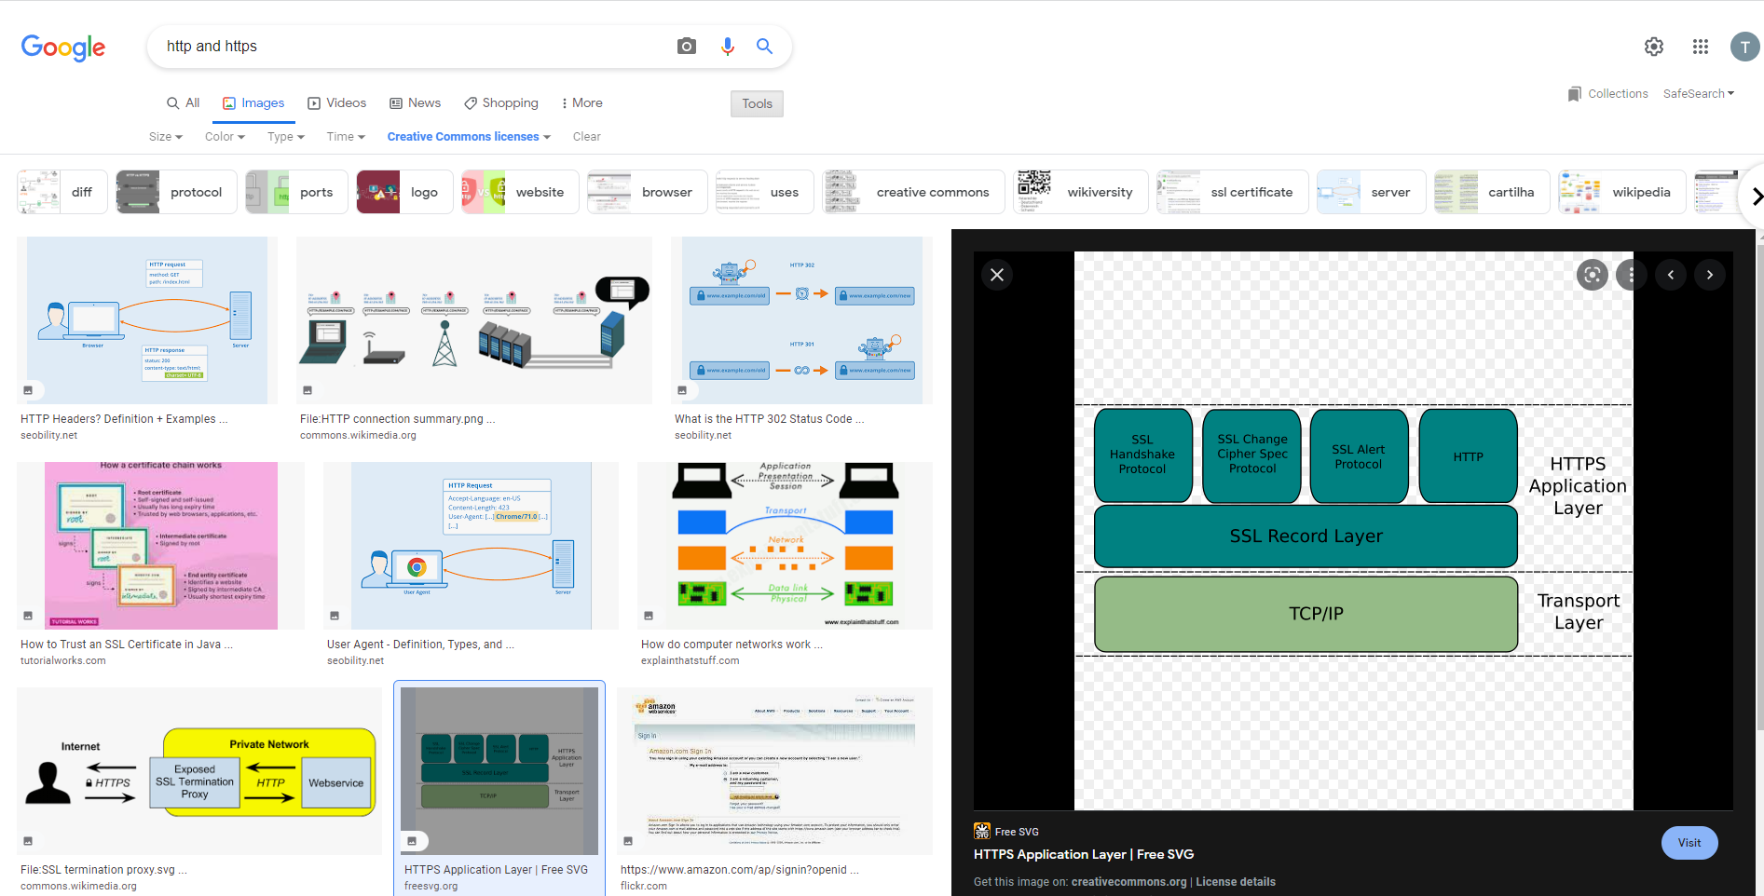

<https://freesvg.org/1in9ui5t-https-application-layer>

Image was found using creative commons license usage rights.

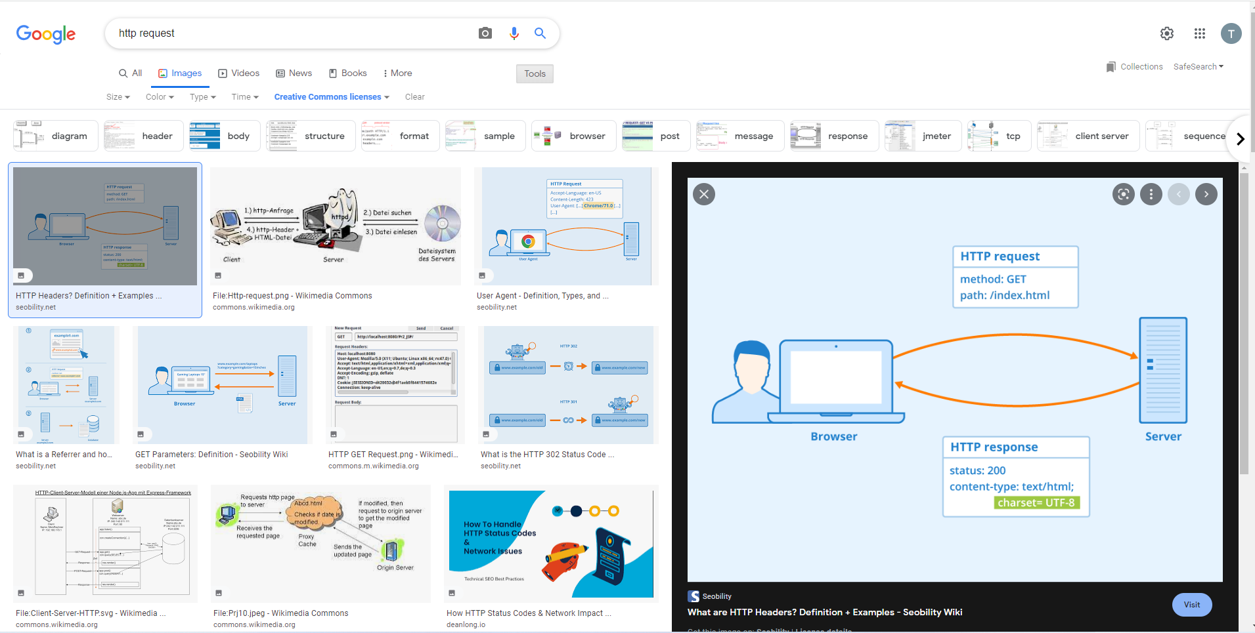

https://www.seobility.net/en/wiki/HTTP_headers

HTTP Header - Author: Seobility - License: [CC BY-SA 4.0](https://www.seobility.net/en/wiki/Creative_Commons_License_BY-SA_4.0)

Image was found using creative commons license usage rights.

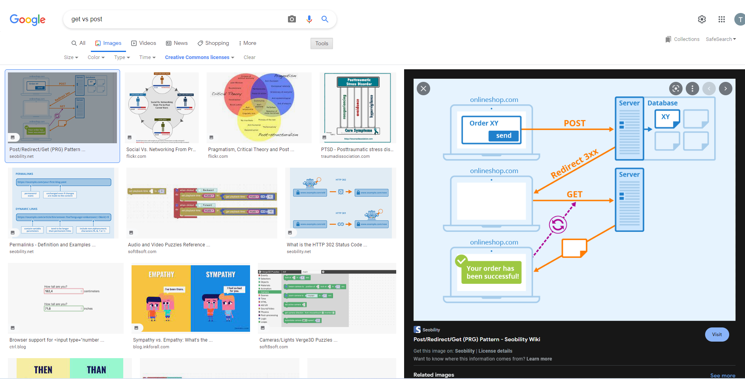

https://www.seobility.net/en/wiki/Post/Redirect/Get

Post/Redirect/Get - Author: Seobility - License: [CC BY-SA 4.0](https://www.seobility.net/en/wiki/Creative_Commons_License_BY-SA_4.0)

Image was found using creative commons license usage rights.